**Jobsheet-05: PHP 2**

**Course: Web Programming / Web Design and Programming**

Erwan Majid / 08/2i

Link github: <https://github.com/Majid5654/Semester-3/tree/master/Week5>

* **Practical Section 1. Indexed Array**

1. To display an array, in addition to using indexes, we can also use loops. Try displaying the

output of the program above using a loop.(Question No.1)

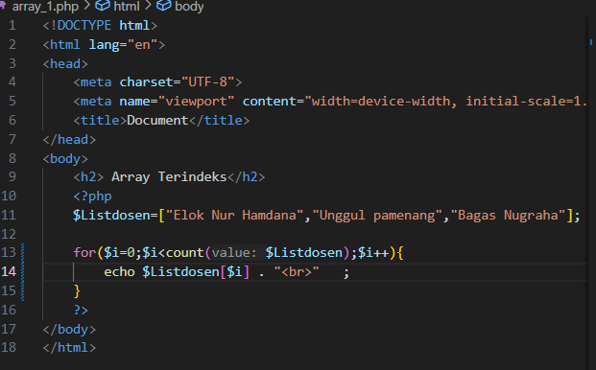

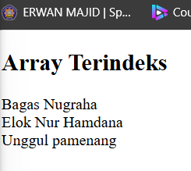

* **Practical Section 2. Associative Array**

1. Observe the output displayed. Then, add table styling to the output to make it more visually appealing. Here’s the updated code with a simple table style. (Question No.2)

*For styling, you can choose either internal or external CSS.

- An associative array $Dosen is created with three key-value pairs:

'nama' (name): "Elok Nur Hamdana"

'domisili' (residence): "Malang"

'jenis_kelamin' (gender): "Perempuan" (female)

The echo statements print the values of the array in HTML format:

It outputs the name, residence, and gender in plain text.

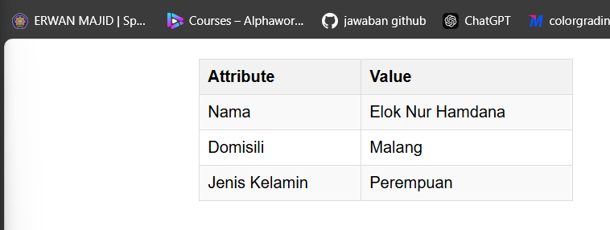

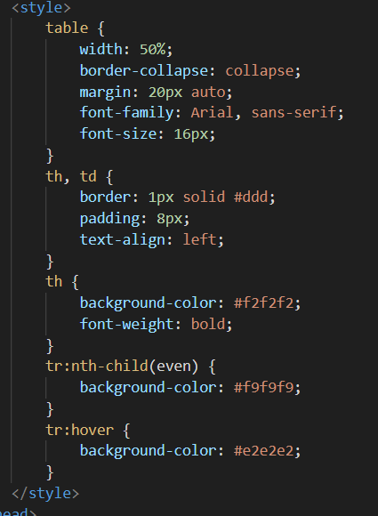

* **Practical Section 3. Multidimensional Array**

1. Observe the output displayed and explain your observations (Question No 3)

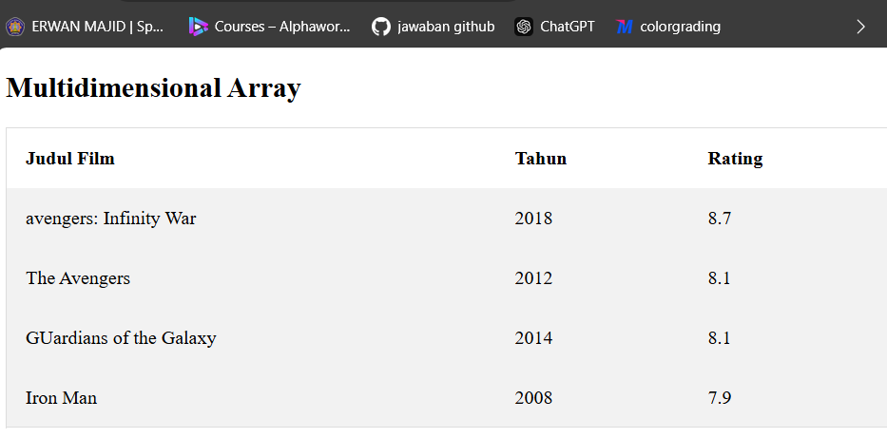

- <tr>: Defines a table row.

-<th>: Defines table headers for "Judul Film," "Tahun," and "Rating."

- $movie = array(...): Defines a multidimensional array containing movies, each with a title, year, and rating

- echo "<tr>"...: Repeatedly outputs rows for each movie in the array.

- echo "<td>"...: Outputs individual cells (<td>) for each movie’s title, year, and rating.

-echo "<td>". $movie[0][0] ."</td>";: Outputs "Avengers: Infinity War" in the first cell.

-echo "<td>". $movie[0][1] ."</td>";: Outputs "2018" in the second cell.

-echo "<td>". $movie[0][2] ."</td>";: Outputs "8.7" in the third cell.

* **Practical Section 4. Function**

1. Save the file and run the code. Modify the program so that it can display the output twice. Explain your observations! (Question No 4)

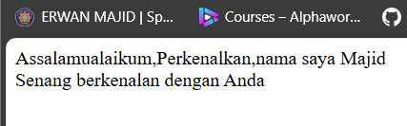

Modify:

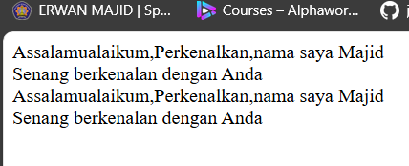

Code:

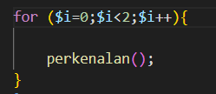

-make a function perkenalan,which in function perkenalan display echo assalamualikum and perkenalkan

-and called by for,then type the name of function

1. Observe the output displayed and explain your observations! (Question No 5)

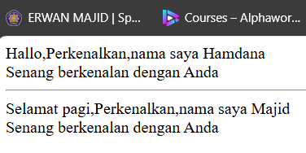

- function perkenalan($nama, $salam): Defines a function perkenalan that takes two arguments: $nama and $salam.

Inside the function:

echo $salam . ",";: Outputs the greeting ($salam) followed by a comma.

echo "Perkenalkan, nama saya ".$nama."<br/>";: Outputs "Perkenalkan, nama saya" followed by the $nama value.

echo "Senang berkenalan dengan Anda <br/>";: Outputs "Senang berkenalan dengan Anda" with a line break.

First call

perkenalan("Hamdana", "Hallo");: Calls the function with "Hamdana" as the name and "Hallo" as the greeting, printing the personalized message.

Second Call with Variables:

$saya = "Majid";: Defines the $saya variable with the value "Majid".

$ucapanSalam = "Selamat pagi";: Defines the $ucapanSalam variable with the value "Selamat pagi".

perkenalan($saya, $ucapanSalam);: Calls the function with these variables, printing another personalized message.

1. Observe the output displayed and explain your observations! (Question No 6)

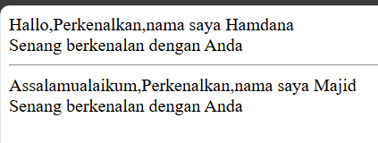

- function perkenalan($nama, $salam="Assalamualaikum"): The $salam parameter now has a default value of "Assalamualaikum".

If the function is called without providing a second argument ($salam), it will automatically use "Assalamualaikum" as the greeting

1. Observe the output displayed and explain your observations! (Question No 7)

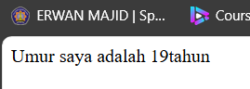

-function hitungUmur that calculates a person's age based on their birth year ($thn_lahir) and the current year ($thn_sekarang). The function subtracts the birth year from the current year to determine the age,then return $umur;: Returns the calculated age to where the function was called. it print with echo umur saya adalah and call the function hitung umur

1. Observe the output displayed and explain your observations! (Question No 8)

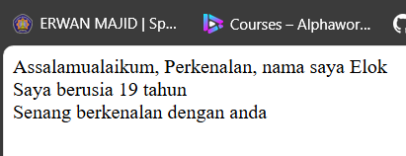

-there is a function named perkenalan with two parameters,nama and salam(default assalamualaikum)

Echo $salam output greeting message

echo "Perkenalan, Outputs an introduction message that includes the name passed to the function

echo "Saya berusia ". Outputs the age by calling the previously defined hitungUmur function (calculating the age from 2004 to 2023) and appends "years" after the result.

perkenalan ("Elok"):Calls the perkenalan function with the name "Elok", using the default greeting "Assalamualaikum

1. If the program code above is executed, what will happen and what would be the impact of doing so? Please share your opinions! (Question No 9)

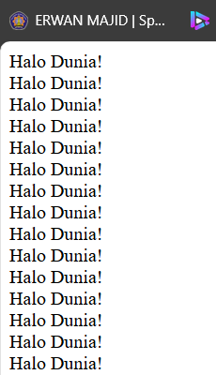

-This is create function type void tampilkanhalodunia,inside function there is a echo to print halo dunia,but inside that function it call the function it self,so this is create an infinity loop

1. Run the program code above and describe its output, then explain why it behaves that way. (Question No 10)

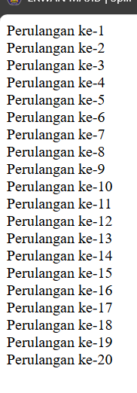

-function tampilkanAngka (int $jumlah, int $indeks = 1): Defines a recursive function tampilkanAngka that takes two integer parameters

-echo "Perulangan ke-{$indeks} <br>": Prints the current iteration number ($indeks) with the text "Perulangan ke-

-if ($indeks < $jumlah): Checks if the current index ($indeks) is less than the total number of iterations ($jumlah)

-tampilkanAngka($jumlah, $indeks + 1): Calls the tampilkanAngka function again, incrementing the index ($indeks + 1), which creates a recursive loop until the condition if ($indeks < $jumlah) is no longer true

-so the output Perulangan ke-1,Perulangan ke-2

* **Practical Section 6. Multi-Level Menu**

1. Run the program above and describe the output. (Question No 11)

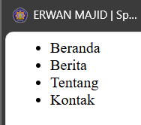

**-**tampilkanMenuBertingkat(array $menu): Defines a function that takes an array ($menu) as an argument.

echo "<ul>";: Prints the opening <ul> tag to create an unordered list in HTML.

foreach ($menu as $item): Loops through each item in the $menu array.

echo "<li>{$item['nama']}</li>";: Prints each menu item's name inside an <li> (list item) tag.

echo "</ul>";: Closes the unordered list.

1. Next, make the function above recursive by calling itself when an item from the menu has a

subMenu attribute. This will result in a display like the following (Question No 12)

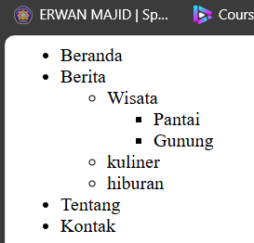

-isset($item['SubMenu']) and isset($item['submenu']). This is done to handle different submenu structures (i.e., "SubMenu" and "submenu").

tampilkanMenuBertingkat($item['SubMenu']): If a SubMenu exists, the function calls itself to print that submenu.

tampilkanMenuBertingkat($item['submenu']): Similarly, if a submenu exists, the function recursively calls itself to print it.

* **Practical Section 7. String**

1. Observe the output displayed and explain your observations. (Question No 13)

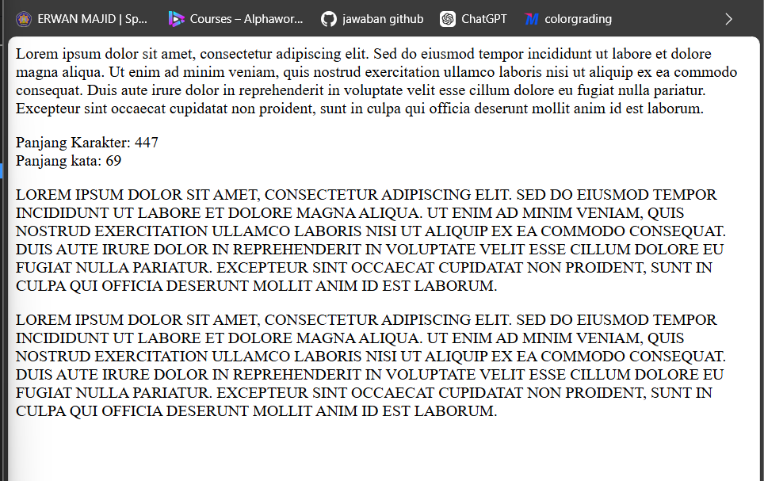

-echo "<p>{$loremIpsum}</p>"; : This prints the $loremIpsum text inside an HTML paragraph

-echo "Panjang Karakter: " . strlen($loremIpsum) . "<br>"; : This function calculates the number of characters in the $loremIpsum

-echo "Panjang kata: " . str_word_count($loremIpsum) . "<br>"; : This function counts the number of words in the $loremIpsum string

-echo "<p>" . strtoupper($loremIpsum) . "</p>"; : This function converts the $loremIpsum text to uppercase

1. From the program code above, you can observe the difference between double quotes and

single quotes in terms of how they handle escape strings. Observe the output and explain the

results of each output. What conclusions can you draw from this experiment? (Question No 14)

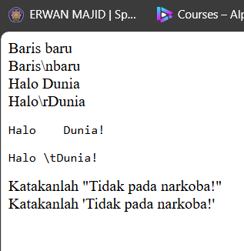 - Double quotes (" "): Interpret escape sequences like \n, \r, \t, \", etc.

-Single quotes (' '): Do not interpret escape sequences (except for \' and \\), treating them as regular characters.

1. Observe the output displayed and explain your observations (Question No 15)

- 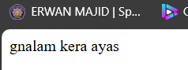

- Function: strrev() : This built-in PHP function takes a string as input and returns the string in reverse order.

1. Observe the output displayed and explain your observations (Question No 16)

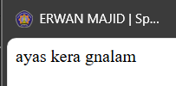

- The explode() function is used to split the string $pesan into an array of words using a space (' ') as the delimiter.

- The array_map() function applies a callback function to each element of the array $pesanPerKata.

- The callback function fn($pesan) => strrev($pesan) is an arrow function (a shorthand for anonymous functions in PHP) that takes a word as input and returns the reversed version of that word using strrev().

- $pesan = implode(" ", $pesanPerKata); The implode() function joins the elements of the array $pesanPerKata back into a single string, using a space (' ') as the separator.

Input: "saya arek malang"

After splitting: ["saya", "arek", "malang"]

After reversing each word: ["ayas", "kera", "gnalam"]

Final output: "ayas kera gnalam"

* **Practical Section 8. HTML and PHP**

1. Which of the two methods do you find easier? Provide your answer along with reasoning. (Question No 17)

-if me i prefer to use php inside html,because to build a display of website almost all in html to design the text put picture and so on,but less in php,maybe if we need operator logic then just create a tag php inside html

* **Practical Section 9. HTML Entities**

1. Observe the output displayed and explain your observations (Question No 18)

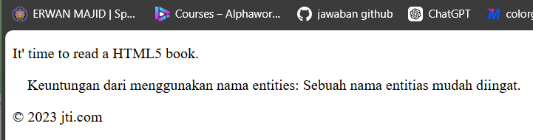

- <p>It&#39; time to read a HTML5 book.</p> his paragraph uses the HTML entity &#39; to represent the apostrophe (')

- <p>&nbsp;&nbsp;&nbsp;&nbsp : &nbsp; to create non-breaking spaces. Each &nbsp; adds a space that will not break into a new line

- <p>&#169; 2023 jti.com</p> : entity &#169; to represent the copyright symbol (©)

1. How can you view HTTP headers in your web browser? Explain and include the steps. (Question No 19)

-in my device I use browser chrome ,then open the website you want to visit

- Open Developer Tools: Right-click on the page and select Inspect

- Navigate to the Network Tab: Click on the Network tab in the Developer Tools panel

-refresh the page

- Select a Request: Click on any request from the list that appears.

-View Headers: In the selected request, look for the Headers tab to see both Request and Response Headers.

* **Practical Section 10. Date**

1. Observe the output displayed and explain your observations! (Question No 19)

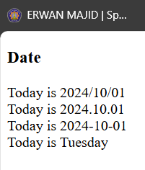

- date("Y/m/d"):This function call formats the current date as Year/Month/Day (e.g., 2024/10/01).

date("Y.m.d"):This formats the date as Year.Month.Day (e.g., 2024.10.01).

date("Y-m-d"):This formats the date as Year-Month-Day (e.g., 2024-10-01).

date("l"):This returns the full textual representation of the day right now of the week

1. 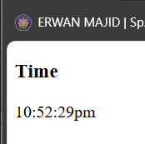Observe the output displayed and explain your observations! (Question No 20)

- dynamically displays the current time in the "Asia/Jakarta" timezone.

* **Practical Section 11. Superglobal Variables**

1. Run the program code above, then explain the output from each echo command. (Soal no.21)

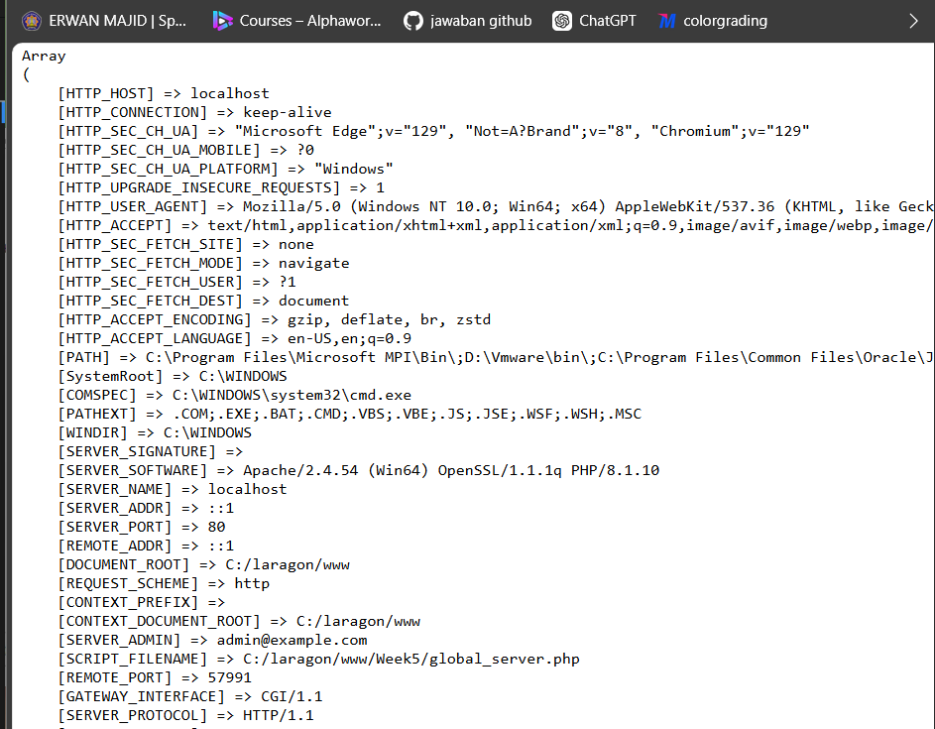

-echo '<pre>'; : is used to define preformatted text.

- print_r($_SERVER); : The print_r() function is used to output human-readable information about a variable.

-$_SERVER is an associative array in PHP that contains information about headers, paths, and script locations.

- echo '</pre>'; : ending the preformatted text section.

1. Run this url on your browser

localhost/week5/global_get.php?nama=Elok&usia=37

What output is produced, observe, and explain the result.

(Question No 22) 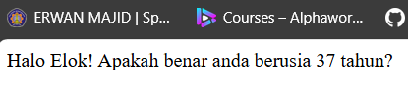

- When you access the URL localhost/week5/global_get.php?nama=Elok&usia=37, the server interprets the query string parameters as follows

nama=Elok: This sets $_GET['nama'] to Elok.

usia=37: This sets $_GET['usia'] to 37.

- The script retrieves the nama and usia parameters from the URL query string, suppresses errors if they are not set, and outputs a greeting that includes the retrieved values

1. Run this url on your browser

localhost/week5/global_post.php

Submit the form and what output is produced? Observe and explain the result. (Question No 23)

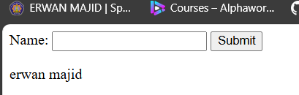

- Name: <input type="text" name="fname"> : Creates a text input field where the user can type their name.

- The form uses the POST method, which sends form data to the same page ($_SERVER['PHP_SELF'] returns the current page's URL)

- The form submits the user's input to the same page. If the name field is filled, it displays the name; if left blank, it outputs "Name is empty

1. Run this url on your browser

localhost/week5/global_request.php

Submit the form and what output is produced? Observe and explain the result. And what is the

difference with the global variable $_POST? (Question No 24)

- 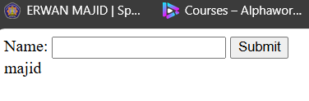

- $_REQUEST: Can retrieve data from both POST, GET, and COOKIE methods. It automatically collects data regardless of how it was sent (whether via POST, GET, or cookies).

1. Run this url on your browser

localhost/week5/global_globals.php

Submit the form and what output is produced? Observe and explain the result. (Question No 25)

- 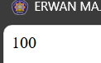

- function addition() {

$GLOBALS['z'] = $GLOBALS['x'] + $GLOBALS['y'];

}: his is a function named addition. It does not take any parameters and operates on the global variables using the $GLOBALS array.

$GLOBALS['x'] and $GLOBALS['y']: The $GLOBALS array is a superglobal that allows you to access global variables inside functions, where normal global variables would not be accessible by default

- The function adds the global variables $x and $y and assigns the result to $GLOBALS['z'], making $z a global variable accessible outside the function.

- The addition() function is called here. This executes the logic inside the function, which calculates the sum of $x and $y and stores the result in the global variable $z